**Erikson's Integrity vs. Despair**

Erikson (1982) represents one of the few personality theorist to examine aging as a stage of development. According to Erikson's theory, personality development goes through a series of eight, hierarchically ordered stages. Associated with each stage is a psychosocial crisis that the individual either successfully resolves or fails to resolve. Failure results in incomplete development of the personality, and inhibits further development of the personality.

The final stage of Erikson's (1982) theory is later adulthood (age 60 years and older). The crisis represented by this last life stage is integrity versus despair. Erikson (1982) proposes that this stage begins when the individual experiences a sense of mortality. This may be in response to retirement, the death of a spouse or close friends, or may simply result from changing social roles.(illness) No matter what the cause, this sense of mortality precipitates the final life crisis. The final life crisis manifests itself as a review of the individual1s life-career. Similar to Butler's (1963) life review, individuals review their life-career to determine if it was a success or failure. According to Erikson (1982), this reminiscence or introspection is most productive when experienced with significant others. The outcome of this life-career reminiscence can be either positive or negative. Ego integrity is the result of the positive resolution of the final life crisis. Ego integrity is viewed as the key to harmonious personality development; the individual views their whole of life with satisfaction and contentment. The ego quality that emerges from a positive resolution is wisdom. Erikson (1982) defines wisdom as a kind of "informed and detached concern with life itself in the face of death itself" (p. 61). Conversely, despair is the result of the negative resolution or lack of resolution of the final life crisis. This negative resolution manifests itself as a fear of death, a sense that life is too short, and depression. Despair is the last dystonic element in Erikson's (1959, 1982) theory.

IM not fearful of death pursay I am fearfiul of beingleft behind by brian dying first or the kids busy living thereown lives and the physical symptoms compiling in such a wayt o bring a new pain more often than Id like and can maange emotionally. I sometime feel complete and done and not wanting to beleft behind abandoneed and left alone I would rather go first…

s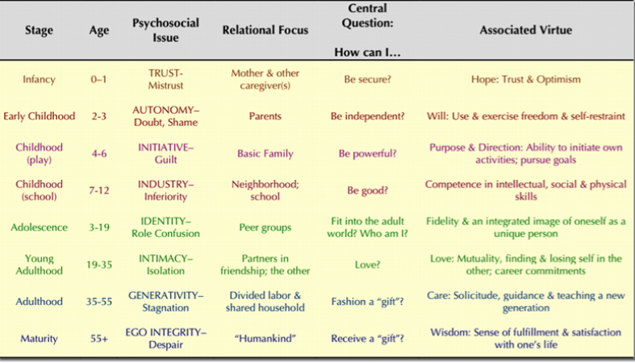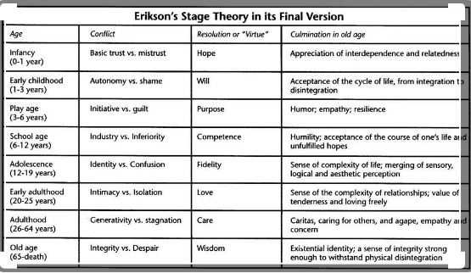

my mom and I ar in the saem phase, and I faired better. Why the need to leave fisrt. Hurts so bad being left. Abonadoned exiled for speaking truth. Or she went totally insane while we were traveling and jumped into the deep a=end or atleast the abyss!

### Ninth stage[[edit](https://en.wikipedia.org/w/index.php?title=Erikson%27s_stages_of_psychosocial_development&action=edit&section=10" \o "Edit section: Ninth stage)]

* Psychosocial Crises: All first eight stages in reverse quotient order

[Joan M. Erikson](https://en.wikipedia.org/wiki/Joan_Erikson), who married and collaborated with Erik Erikson, added a ninth stage in *The Life Cycle Completed: Extended Version*.[[20]](https://en.wikipedia.org/wiki/Erikson%27s_stages_of_psychosocial_development#cite_note-20) Living in the ninth stage, she wrote, "old age in one's eighties and nineties brings with it new demands, reevaluations, and daily difficulties". Addressing these new challenges requires "designating a new ninth stage". Erikson was ninety-three years old when she wrote about the ninth stage.[[21]](https://en.wikipedia.org/wiki/Erikson%27s_stages_of_psychosocial_development#cite_note-21)

Joan Erikson showed that all the eight stages "are relevant and recurring in the ninth stage".[[22]](https://en.wikipedia.org/wiki/Erikson%27s_stages_of_psychosocial_development#cite_note-22) In the ninth stage, the psychosocial crises of the eight stages are faced again, but with the quotient order reversed. For example, in the first stage (infancy), the psychosocial crisis was "Trust vs. Mistrust" with Trust being the "syntonic quotient" and Mistrust being the "dystonic".[[23]](https://en.wikipedia.org/wiki/Erikson%27s_stages_of_psychosocial_development#cite_note-23) Joan Erikson applies the earlier psychosocial crises to the ninth stage as follows:

**"Basic Mistrust vs. Trust: Hope"**  
In the ninth stage, "elders are forced to mistrust their own capabilities" because one's "body inevitably weakens". Yet, Joan Erikson asserts that "while there is light, there is hope" for a "bright light and revelation".[[24]](https://en.wikipedia.org/wiki/Erikson%27s_stages_of_psychosocial_development#cite_note-24)

**"Shame and Doubt vs. Autonomy: Will"**  
Ninth stage elders face the "shame of lost control" and doubt "their autonomy over their own bodies". So it is that "shame and doubt challenge cherished autonomy".[[25]](https://en.wikipedia.org/wiki/Erikson%27s_stages_of_psychosocial_development#cite_note-25)

**"Inferiority vs. Industry: Competence"**  
Industry as a "driving force" that elders once had is gone in the ninth stage. Being incompetent "because of aging is belittling" and makes elders "like unhappy small children of great age".[[26]](https://en.wikipedia.org/wiki/Erikson%27s_stages_of_psychosocial_development#cite_note-26)

**"Identity confusion vs. Identity: Fidelity"**  
Elders experience confusion about their "existential identity" in the ninth stage and "a real uncertainty about status and role".[[27]](https://en.wikipedia.org/wiki/Erikson%27s_stages_of_psychosocial_development#cite_note-27)

**"Isolation vs. Intimacy: Love"**  
In the ninth stage, the "years of intimacy and love" are often replaced by "isolation and deprivation". Relationships become "overshadowed by new incapacities and dependencies".[[28]](https://en.wikipedia.org/wiki/Erikson%27s_stages_of_psychosocial_development#cite_note-28)

**"Stagnation vs. Generativity: Care"**  
The generativity in the seventh stage of "work and family relationships", if it goes satisfactorily, is "a wonderful time to be alive". In one's eighties and nineties, there is less energy for generativity or caretaking. Thus, "a sense of stagnation may well take over".[[29]](https://en.wikipedia.org/wiki/Erikson%27s_stages_of_psychosocial_development#cite_note-29)

**"Despair and Disgust vs. Integrity: Wisdom"**  
Integrity imposes "a serious demand on the senses of elders". Wisdom requires capacities that ninth stage elders "do not usually have". The eighth stage includes retrospection that can evoke a "degree of disgust and despair". In the ninth stage, introspection is replaced by the attention demanded to one's "loss of capacities and disintegration".[[30]](https://en.wikipedia.org/wiki/Erikson%27s_stages_of_psychosocial_development#cite_note-30)

Living in the ninth stage, Joan Erikson expressed confidence that the psychosocial crisis of the ninth stage can be met as in the first stage with the "basic trust" with which "we are blessed".[[31]](https://en.wikipedia.org/wiki/Erikson%27s_stages_of_psychosocial_development#cite_note-31)

### Care: generativity vs. stagnation (middle adulthood, 40–59 years)[[edit](https://en.wikipedia.org/w/index.php?title=Erikson%27s_stages_of_psychosocial_development&action=edit&section=8)]

* Existential Question: Can I Make My Life Count?

[Generativity](https://en.wikipedia.org/wiki/Generativity) is the concern of guiding the next generation. Socially-valued work and disciplines are expressions of generativity.

The adult stage of generativity has broad application to family, relationships, work, and society. "Generativity, then is primarily the concern in establishing and guiding the next generation... the concept is meant to include... productivity and creativity."[[19]](https://en.wikipedia.org/wiki/Erikson%27s_stages_of_psychosocial_development#cite_note-Slater2003-19)

During middle age the primary developmental task is one of contributing to society and helping to guide future generations. When a person makes a contribution during this period, perhaps by raising a family or working toward the betterment of society, a sense of generativity—a sense of productivity and accomplishment—results. In contrast, a person who is self-centered and unable or unwilling to help society move forward develops a feeling of stagnation—a dissatisfaction with the relative lack of productivity.

Central tasks of middle adulthood

* Express love through more than sexual contacts.
* Maintain healthy life patterns.
* Develop a sense of unity with mate.
* Help growing and grown children to be responsible adults.
* Relinquish central role in lives of grown children.
* Accept children's mates and friends.
* Create a comfortable home.
* Be proud of accomplishments of self and mate/spouse.
* Reverse roles with aging parents.
* Achieve mature, civic and social responsibility.
* Adjust to physical changes of middle age.
* Use leisure time creatively.

### Wisdom: ego integrity vs. despair (late adulthood, 60 years and above)[[edit](https://en.wikipedia.org/w/index.php?title=Erikson%27s_stages_of_psychosocial_development&action=edit&section=9)]

* Existential Question: Is it Okay to Have Been Me?

As we grow older and become senior citizens we tend to slow down our productivity and explore life as a retired person. It is during this time that we contemplate our accomplishments and are able to develop [integrity](https://en.wikipedia.org/wiki/Ego_integrity) if we see ourselves as leading a successful life. If we see our life as unproductive, or feel that we did not accomplish our life goals, we become dissatisfied with life and develop [despair](https://en.wikipedia.org/wiki/Despair), often leading to depression and hopelessness.

The final developmental task is retrospection: people look back on their lives and accomplishments. They develop feelings of contentment and integrity if they believe that they have led a happy, productive life. They may instead develop a sense of despair if they look back on a life of disappointments and unachieved goals.

This stage can occur out of the sequence when an individual feels they are near the end of their life (such as when receiving a terminal disease diagnosis).